# Music Db

You are working on a team that is building a music database. The team is currently building some REST services. You are responsible for building the REST services to manage the Artist, Album and Song entities. The architect has defined the entities as follows:

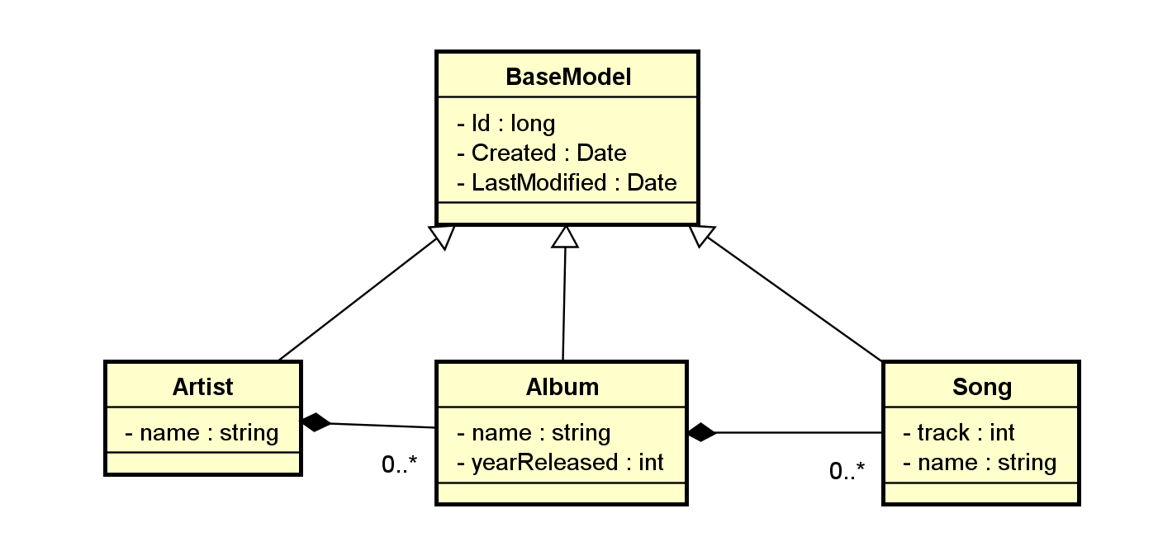

The team has adopted Microsoft WebApi as the framework of choice for all server side development. SQL Server, Entity Framework and code first migrations should be used. Further, the architect has mandated the following technical requirements:

* REST services should support all http verbs required for CRUD operations.
* Entity Framework Database migrations should be used to manage schema and data creation/changes.
* During development you are free to use a MS SQL Local Db (File)

Your task is to implement the Artist service to support GET(All), GET(By Id), POST and DELETE operations.

**\*\*\*\*\* NOTE: Push your changes to your own github repo (NOT THIS ONE!) and send back the uri. \*\*\*\*\***